

**Assignment -02**

**Name of Assignment:** Activity Diagram of ATM Machine

**Title:** System Analysis & Design.

**Course Code:** CSE-325 Course.

**Submitted to:**

**Supta Richard Philip**

**Senior Lecturer**

**Department of CSE**

**City University, Bangladesh.**

**Submitted by:**

|  |  |
| --- | --- |
| **Name** | **: Sharmin Akther** |
| **ID No.** | **: 171442591** |
| **Program** | **: B.Sc in CSE (Eve)** |
| **Semester** | **: 7th Semester** |
| **Date of assigned** | **: 27/06/2019** |

**Contents:**

What is Activity Diagram? 2

How the work ATM machines 3

Reference 5

# What is Activity Diagram?

Activity Diagrams describe how activities are coordinated to provide a service. Activity Diagrams consist of activities, states and transitions between activities and states. You can use activity diagram to model the logic of a single use case, or even how to coordinate a collection of use cases for the entire targeted system being developed. For example, to model how the events in a single use case relate to one another - in particular, use cases where activities may overlap and require coordination.

# How the work ATM Machines:

When you need money, you can stop at an ATM, enter a PIN and leave with cash. How do these wonder machines that give you money and the network that approves the transactions work?

When you need money, you can stop at an ATM, enter a PIN and leave with cash. How do these wonder machines that give you money and the network that approves the transactions work?

When you insert your card into the card reader, it responds to the prompts on the screen, and within a minute you walk away with your money and a receipt (assuming you have a Bank account and a valid ATM Card).ATM (Automatic Teller Machine) is a banking terminal that accepts deposits and dispenses cash. ATMs are activated by inserting cash (in cases of ATM Depositing) or debit /credit card that contain the user’s account number and PIN on a magnetic stripe (for cash withdrawals).

This serves as yet another Bank Branch, though some of you think that the ATM is an unattended device, you might be surprised to find that, the other side of the ATM (the hidden inside) has people constantly rendering services to the clients. Many of them are monitored online to make sure that, the money does not run out, they don’t get tampered with, the network is online etc. The ATM is made of the CPU (microprocessor). It is this that carries out the processing roles like authentication, networking, validation of currency notes, etc. I suppose it is for the above reason that most of the ATMs are designed for the debit cards in a bid to reduce the likelihood of people overdrawing their credit balances. There is confusion between the Bankers’ definition of Credit and that of the Accountants. To Bankers, when you have a credit balance, your account is healthy because you are the bank’s creditor and vice versa; yet to the Accountant, the reverse is true. When a Bank issues you with a Credit card, they become your creditor as compared to the debit card that is pegged to your account balance.

## Task Name: Activity Diagram for ATM :

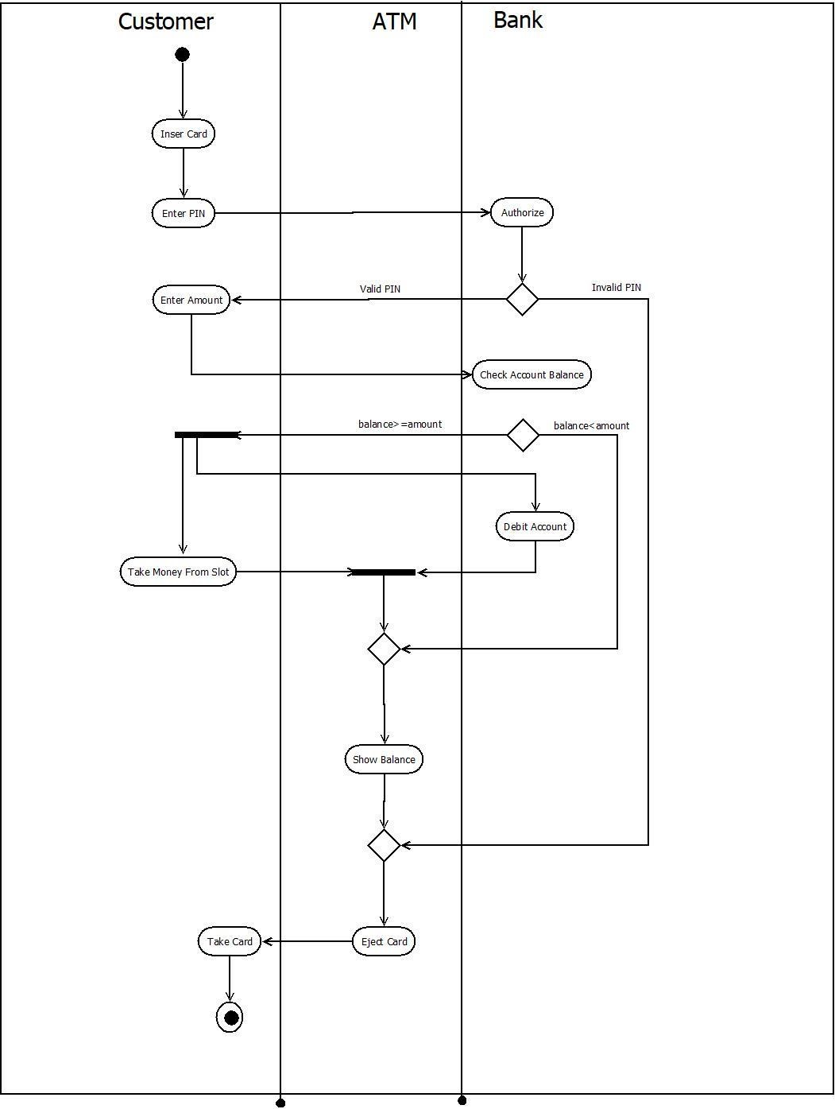

# Reference:

# 

<https://money.howstuffworks.com/personal-finance/banking/atm3.htm>

<https://www.elprocus.com/automatic-teller-machine-types-working-advantages/>